**CLASS GRADES**

#Loading the dataset

data3<-read.csv(file.choose())

colnames(data3)

"Prefix" "Assignment" "Tutorial" "Midterm" "TakeHome" "Final"

nrow(data3)

99

str(data3)

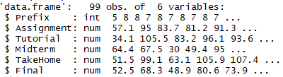

head(3)

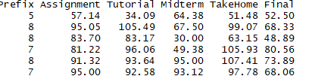

sum(is.na(data3))

***5 missing values – 2 missing in Mid-Term and 3 missing in Take Home***

summary(data3)

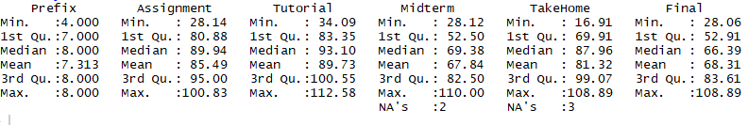

data3 %>% gather(Prefix:Final, key = "variable", value = "value") %>% ggplot(aes(x = value)) +

geom_histogram(bins = 30) + facet_wrap(~ variable, scales = 'free_x')

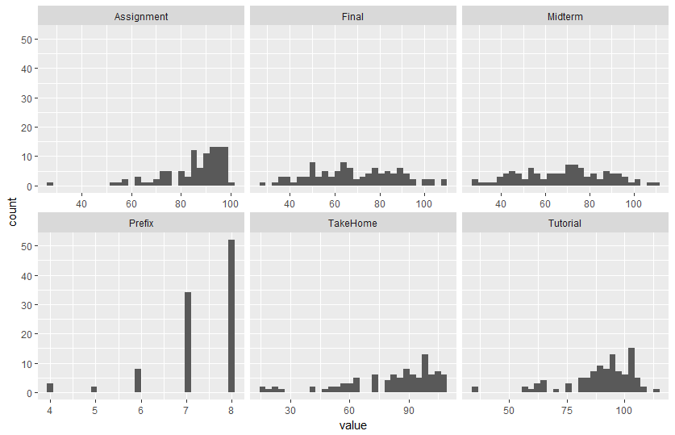

data3 %>% gather(Prefix:Final, key = "variable", value = "value") %>% ggplot(aes(x=variable,y = value)) + geom_boxplot() + facet_wrap(~ variable, scales = 'free_y')

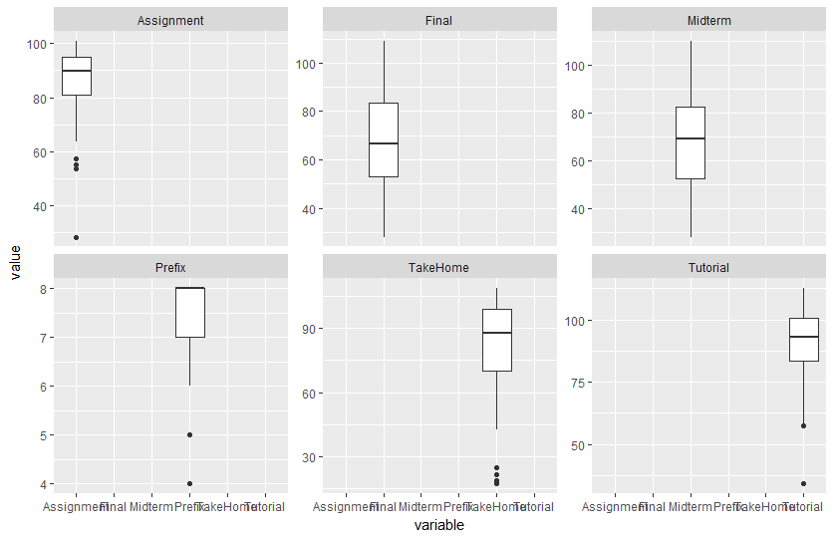

***Assignment, Take Home and Tutorial are left skewed with outliers.***

pairs(data3, gap = 0, pch = 21)

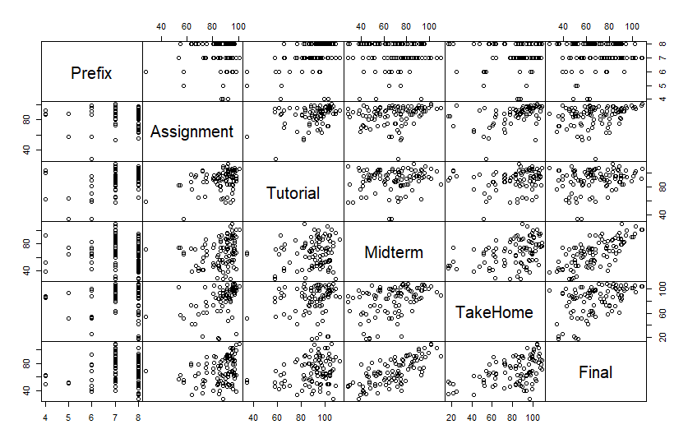

**Regression Imputation technique**

First we shall create a linear regression model.

linear_model = lm(Final~.,data=data3)

summary(linear_model)

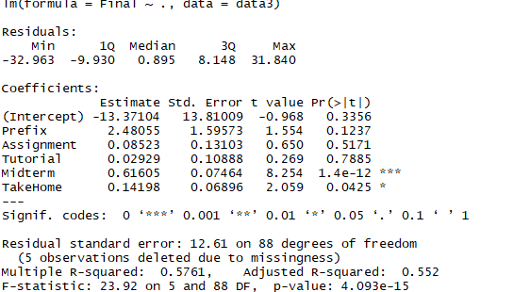

The summary shows that Midterm and TakeHome are significant variables.

Now, we shall regress Take Home on all the remaining attributes

TakeHome_all <- lm(TakeHome~Prefix+Assignment+Tutorial+Midterm,data=data3)

first_df<- data.frame(Prefix=c(7,6,8),Assignment=c(72.85,90.74,71.79),Tutorial=c(86.85,89.64,102.87),Midterm=c(60,61.25,41.88))

#Predicting the missing values

TakeHome_all.pred = predict(TakeHome_all,first_df)

TakeHome_all.pred



Hence, we have the missing values in Take Home predicted as below:

data3$TakeHome[8]=68.64

data3$TakeHome[39]=84.93

data3$TakeHome[61]=59.40

Now, we shall regress Mid Term on all the remaining attributes

MidTerm_all<-lm(Midterm~Prefix+Assignment+Tutorial+TakeHome,data=data3)

second_df<-data.frame(Prefix=c(8,8),Assignment=c(63.4,82.45),Tutorial=c(86.21,86.65))

MidTerm_all.pred = predict(MidTerm_all,second_df)

MidTerm_all.pred



Hence, we have the missing values in MidTerm predicted as below:

data3$Midterm[21]=59.43

data3$Midterm[27]=64.58

**HotDeck Imputation technique**

library(HotDeckImputation)

data3_matrix = as.matrix(data3)

fitHD= impute.NN_HD(DATA=data3_matrix,distance="man")

fitHD

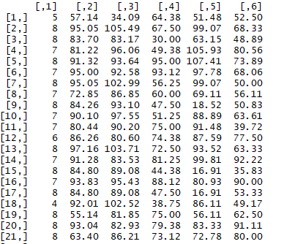

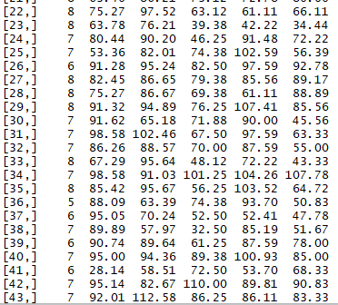

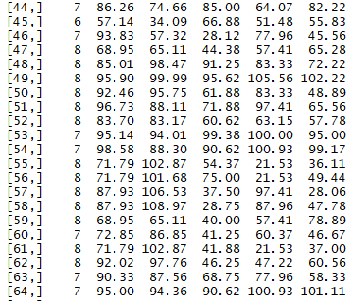

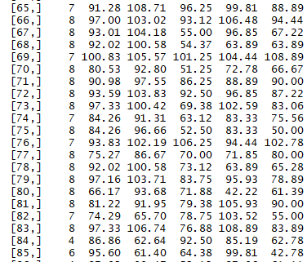

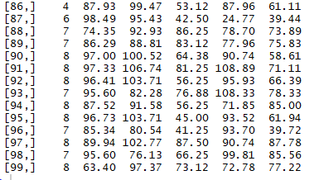

**Table of the imputed values from both the techniques**

We can write the Imputed values from HotDeck Imputation into a csv file

*write.csv(fitHD, file = "Imputed.csv")*

*For Saving it in Tabular Form, we can write as:*

*as.table(fitHD)*

*and*

*as.table(MidTerm_all.pred,TakeHome_all.pred) # From Regression Imputation*